DOWNTON BAPTIST CHURCH HOLIDAY CLUB 2024
www.downtonbaptist.org | 01725 512971
Dates of attendance to Holiday Club |  |  | 25th July |  | 26th July
Personal Data
Name of child (one per form)

Date of birth
School Year just completed
Year R to Year 13
Name of Parent / emergency contact

Name of person to collect child (if different)

Address

Telephone number (s)

Email Address

Doctors Name and Address

Doctors Telephone Number
Consent
CONSENT: I agree to photographs being taken of my child and displayed at church
CONSENT: I agree to photographs being held on computer by Downton Baptist Church
CONSENT: I agree to photographs of my child being used on the Downton Baptist Church website (without names)
CONSENT: I agree my email address and my address can be held and used for the purposes of Holiday Club
CONSENT: I would like my email address added to the mailing list to receive information about church activities. (You can be removed at any time).
In the event of an accident, I give my permission for any necessary medical treatment to be given by the nominated first aider and consent for hospital treatment, including anaesthetic.
Conditions, allergies or special educational needs that my child has, and things to be aware of.

I confirm all the consents for photographs, health, and data above and consent to my child taking part in Holiday Club. |  | Signature:  Date:

Downton Baptist Church, South Lane, Downton, SP5 3NA. Registered Charity: 1131186
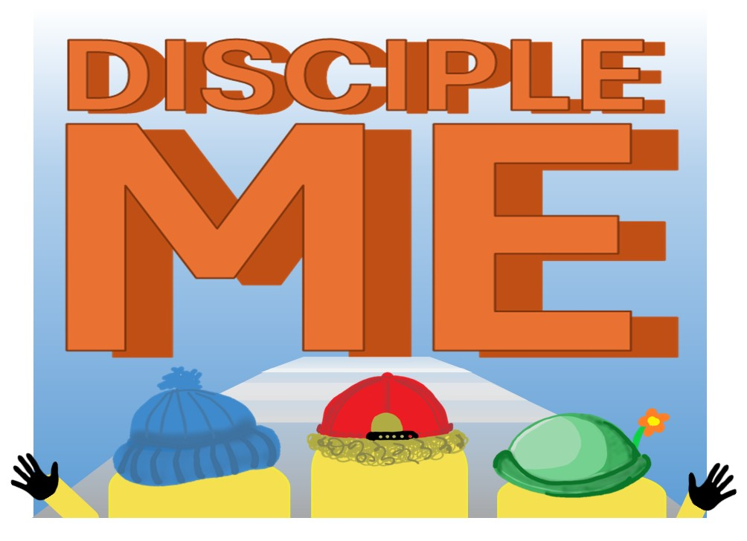
HOLIDAY CLUB 2024 |Thur 25th to Fri 26th July

